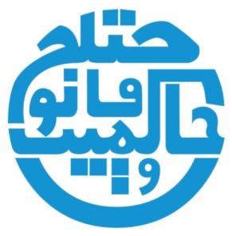
موسسه حمیده برمکی برای حاکمیت قانون
Hamida Barmaki Organization for the Rule of Law

HBORL Working Paper No. 2015/XX
Editors: Dr. Tilmann J. Röder & Sayed Hameed Zia

Name of Author
Title of Paper

This HBORL Working Paper contains preliminary research results. The views, findings, conclusions and recommendations contained herein are strictly those of the author(s). A final version of this paper will be published in Dari language in the
Yearbook of Afghan Legal Studies (YALS).
If cited or quoted, reference should be made to the name(s) of the author(s), the
title and the serial number.
HBORL Working Papers are available online at www.hborl.org.af.

Abstract

(Text)

Name of Author*
Title of Paper

Table of Contents
Introduction 2
I. Chapter 1 2
I.1. Subheading 1 (If necessary) 2
I.2. Subheading 2 (If necessary) 2
II. Chapter 2 3
III. Chapter 3 3
Conclusion 3

Introduction
(Text)

Chapter 1
(Text)

I.1. Subheading 1 (If necessary)
(Text)

I.2. Subheading 2 (If necessary)
(Text)

Chapter 2
(Text)

Chapter 3
(Text)

Conclusion
(Text)

* Short biography of author (2 to 3 sentences).
Footnotes in accordance with the Oxford Standard for the Citation of Legal Authorities (OSCOLA).

